Game programming

Enemy movement/chase

In this tutorial i will explain how to make the enemy search for and chase the player. For this I am going to be using Astar Pathfinding created by Aron Granberg.

1. So to start with go to <https://arongranberg.com/astar/>. Download the free package provided and import it to your unity project.
2. In your hierarchy create an empty game object and name it Pathfinder. Then go to the inspector and reset its transformations.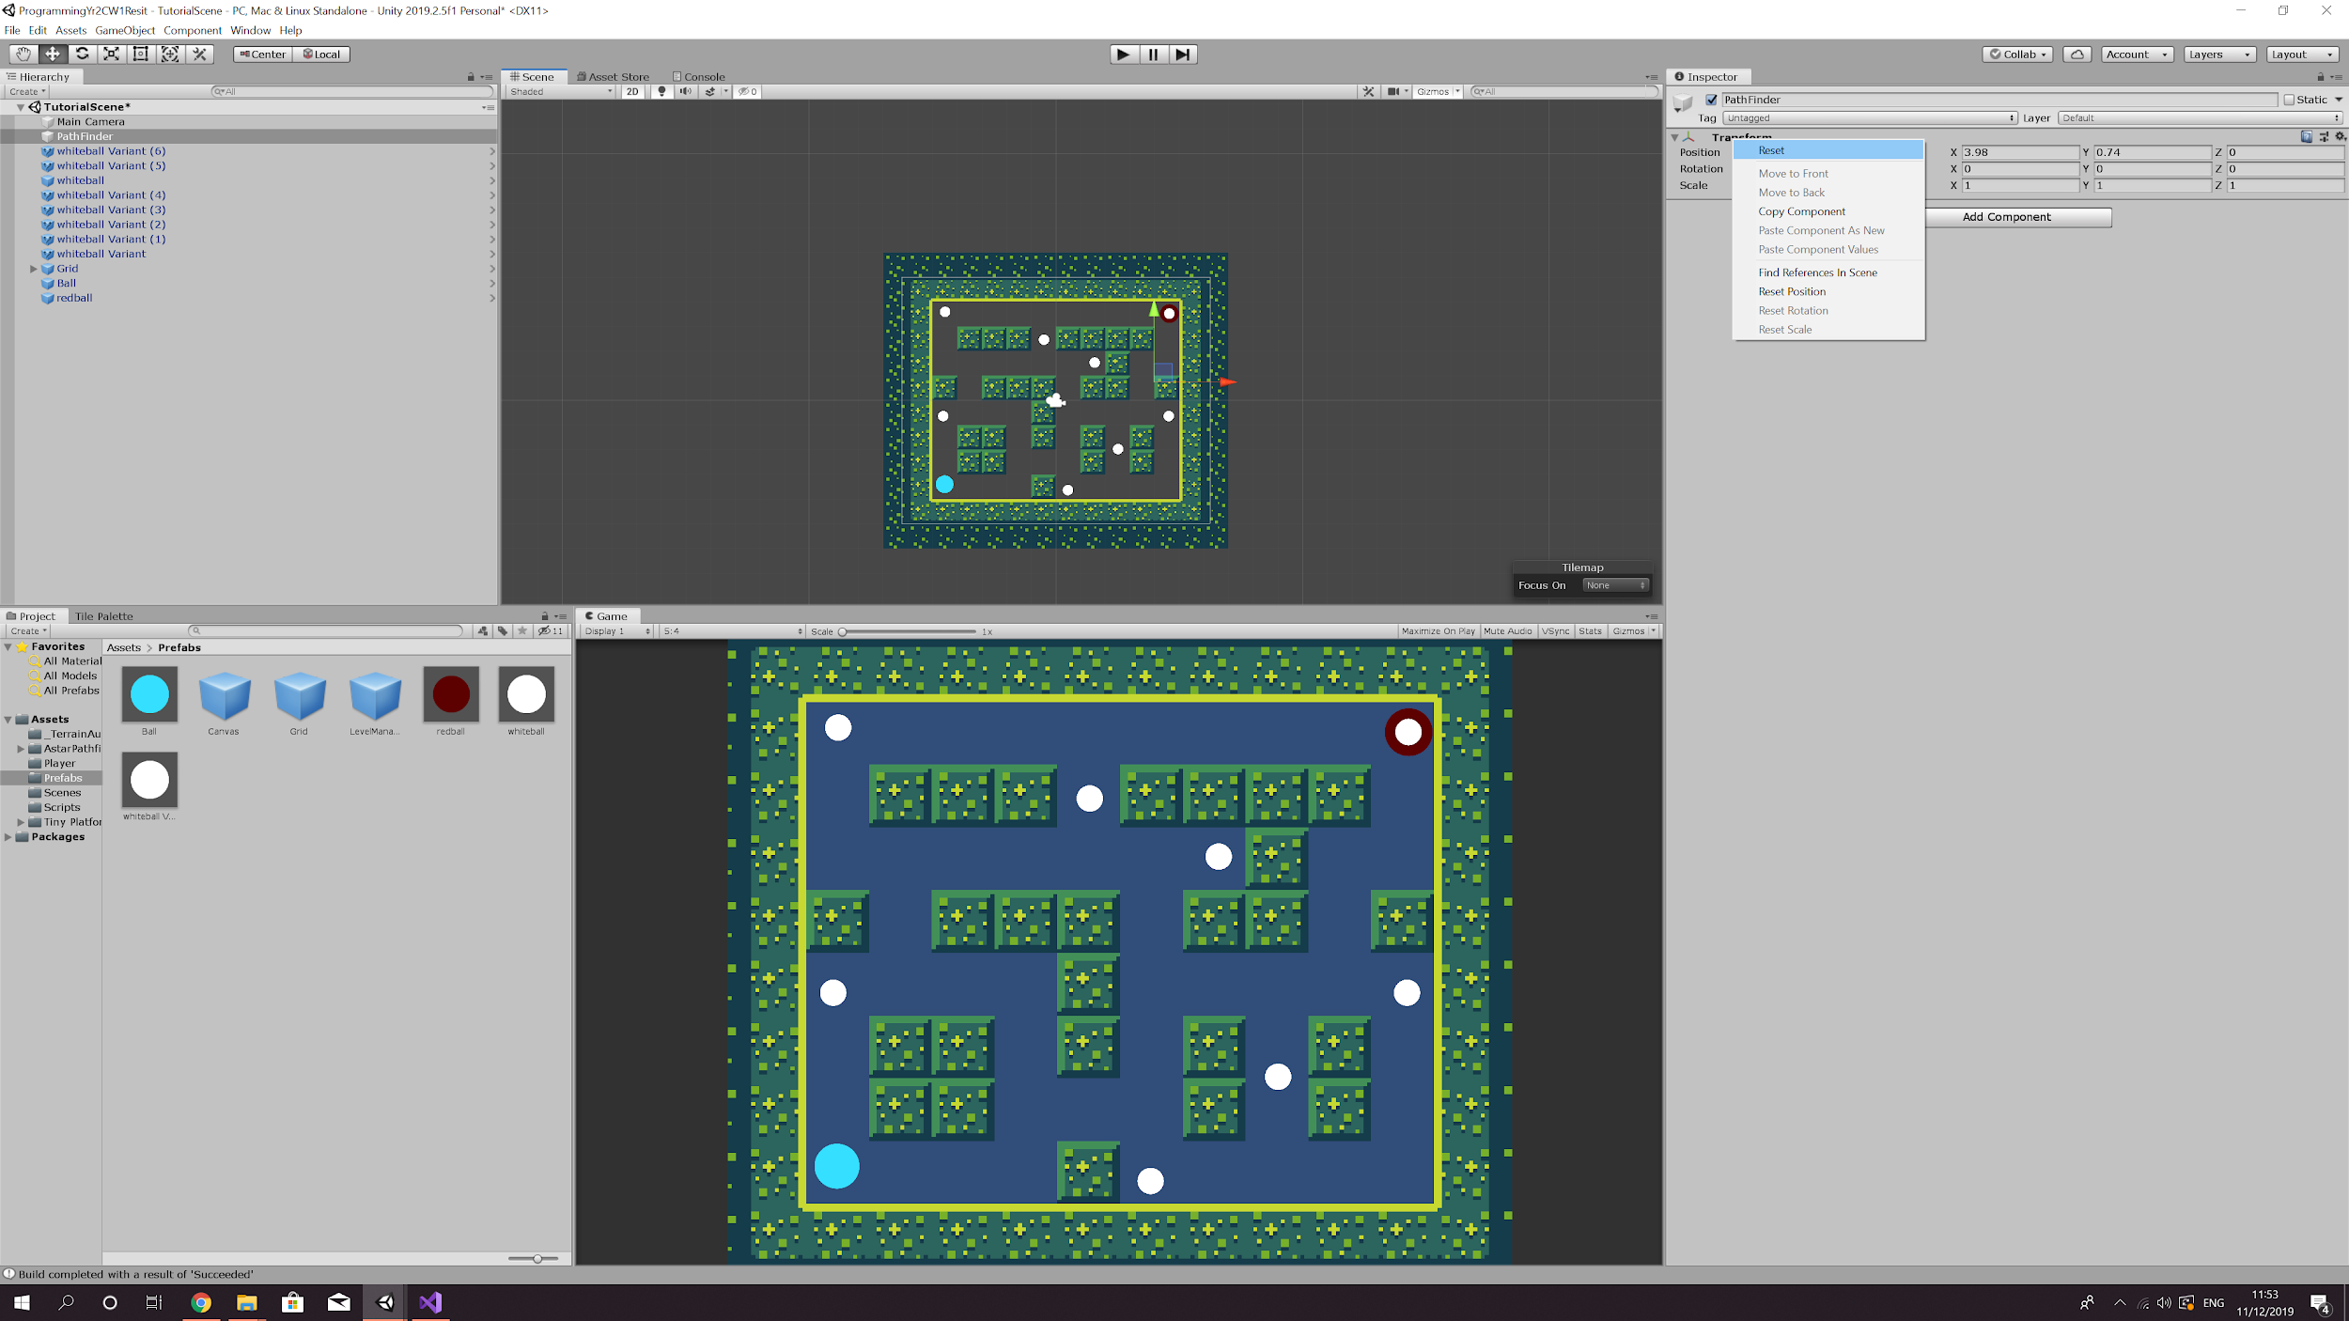
3. Now inside the inspector click add component and type in ‘Pathfinder’. Select the Pathfinder script and and the Astar Path script will pop up in the editor. Under graphs select grid graph and the graph setting should appear. In the settings tick the 2D, use 2D physics and Collision testing. Uncheck Cut Corners, reduce the diameter to around 0.9 and make sure the obstacle layer mask selected matches the layer of your tile map. Go to the settings menu in the script and change the Max Nearest Node Distance to 1000. Now click scan and the area within you tile map that is free to move in should be highlighted in blue.

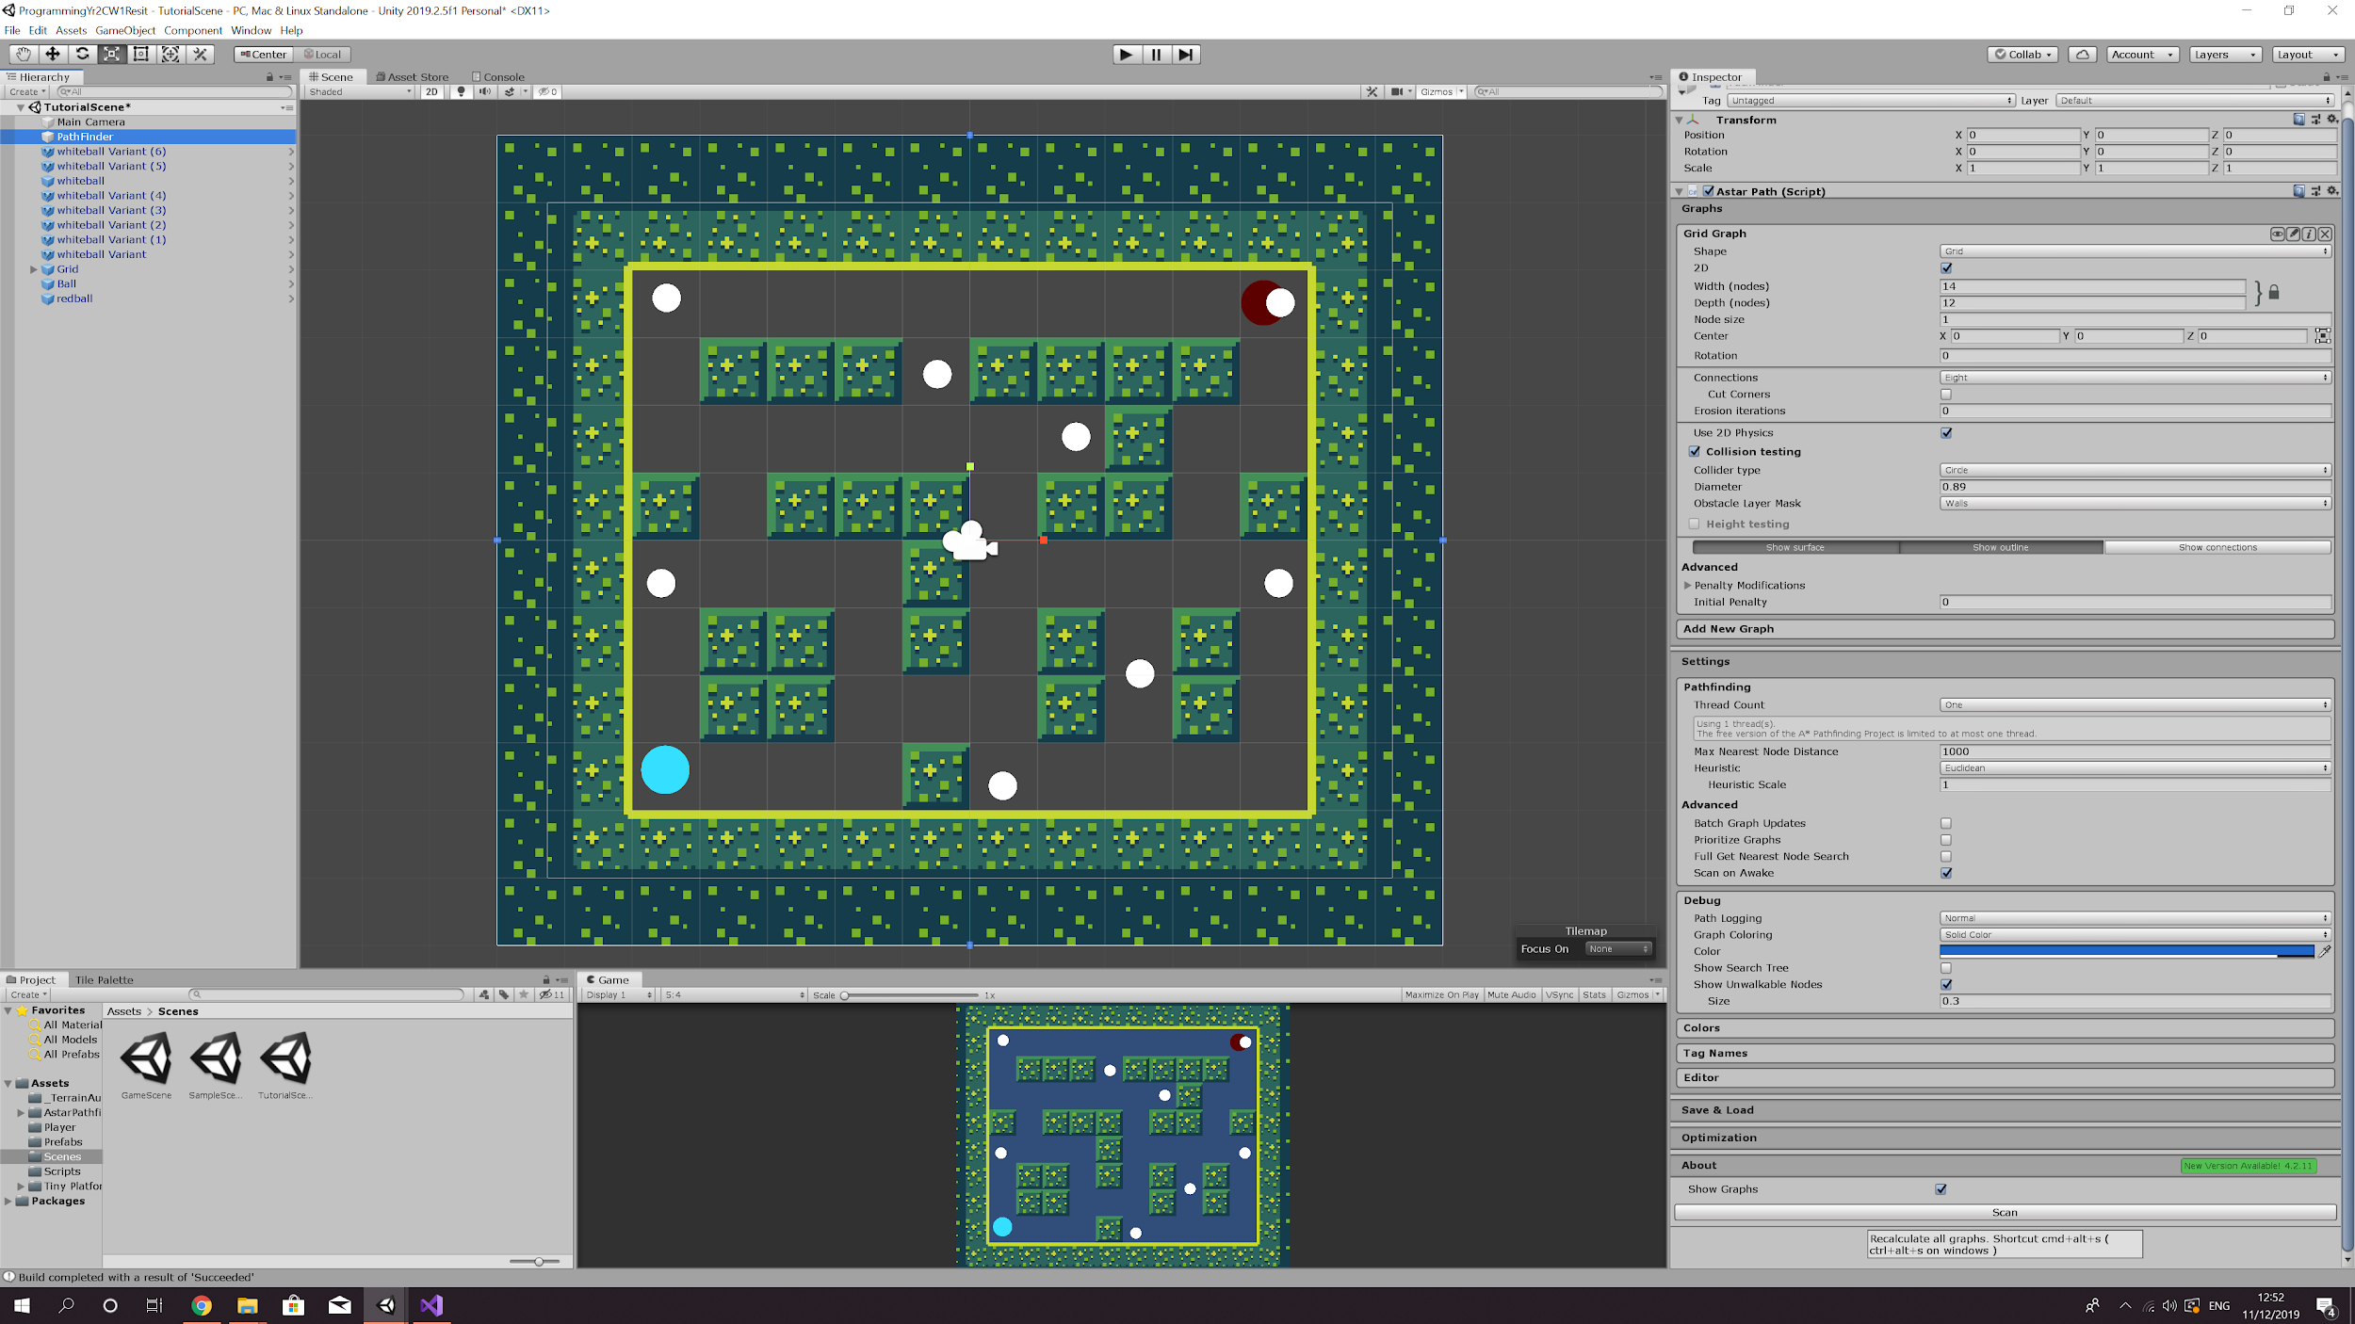

1. Select your enemy from the hierarchy and in the inspector add the following components:

* AI Lerp script
* Seeker script (may come automatically come with the AI Lerp script)
* AI destination setter script

You don’t need to change any of the seeker settings but on the AI lerp script untick enable rotation. Inside the AI destination setter there is a Target box, drag your player from the hierarchy into the box.

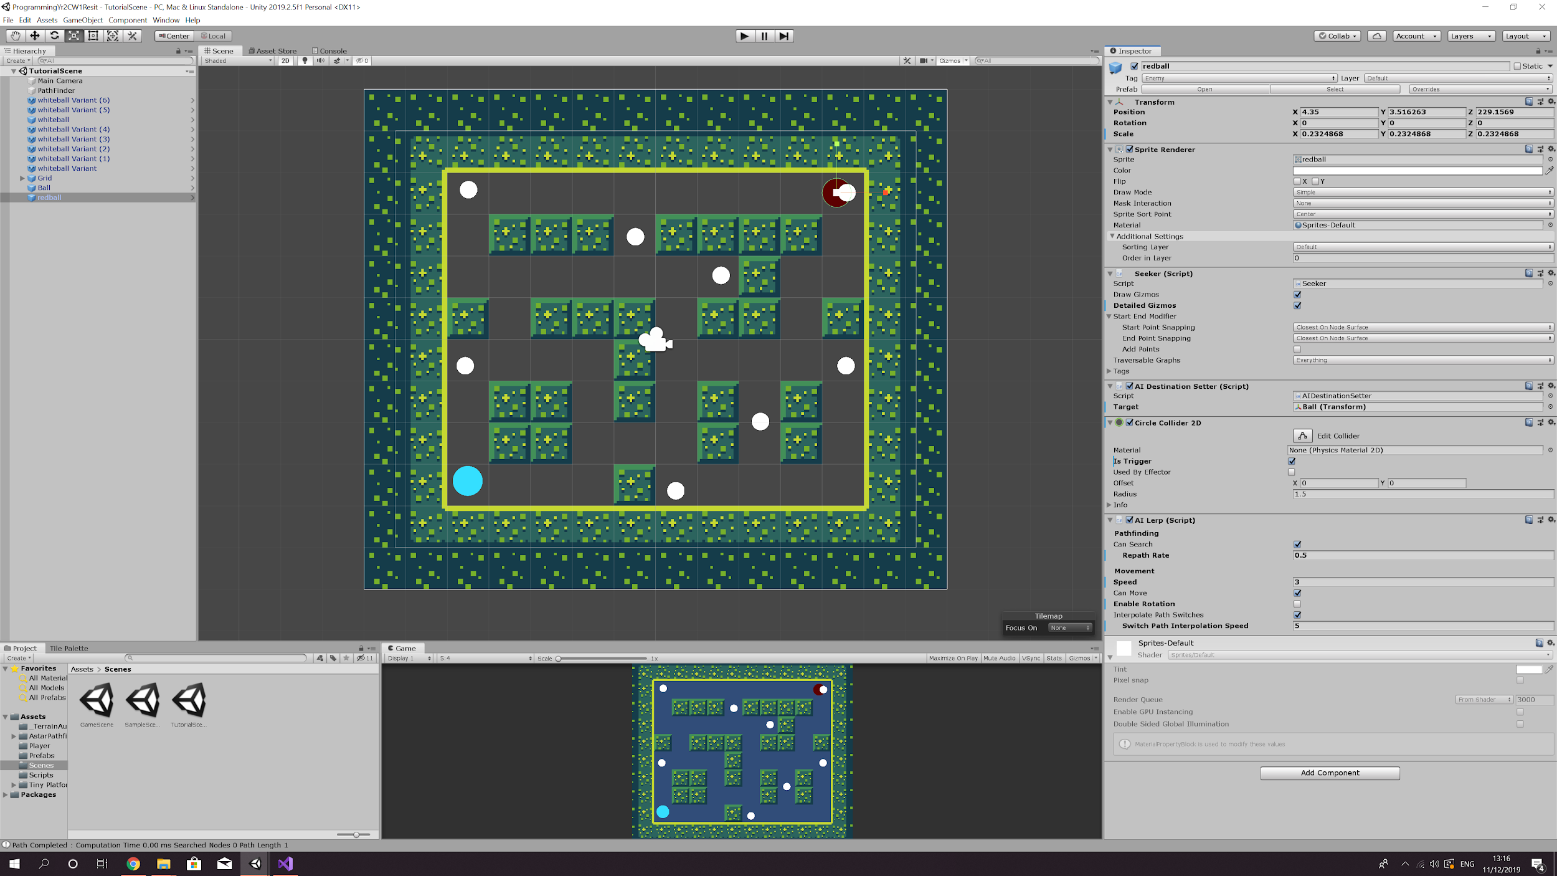

1. Now when you press play your enemy should start to navigate around the grid towards you. However when it gets to you nothing will happen. So to make the enemy kill the player you first need to change the enemy’s tag to ‘ENEMY’. Select your player and add another 2D collider but this time tick ‘is trigger’. You will now want to go to your scripts folder in project and create a new C# script. Name it KillPlayer and open it in your script editor. You won’t be using the start or update function so you can go ahead and delete them. Instead you will want to type void OnTriggerEnter2D this cause you player to die only if the enemy enter its collider. I will show the code in the screenshot below.

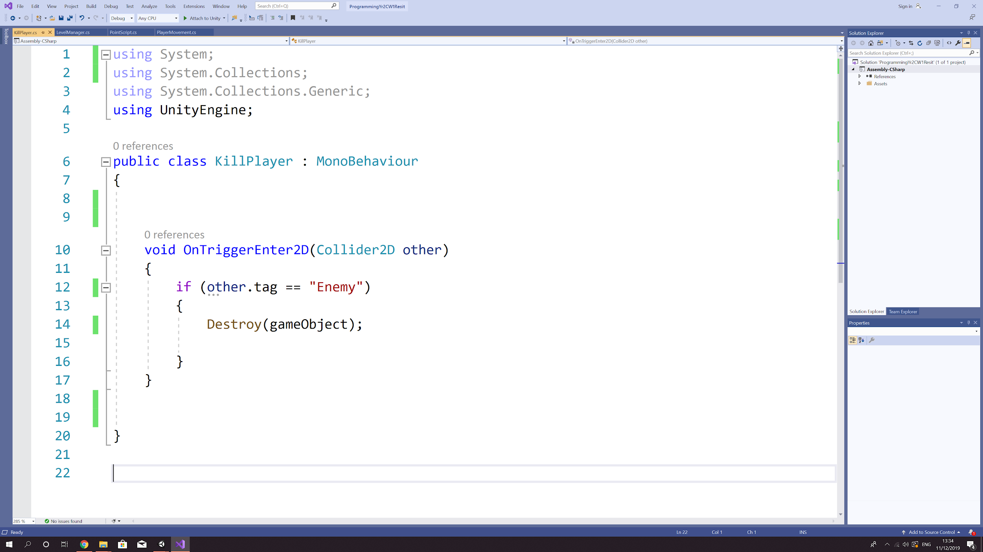

1. Finally attach the script top your player and when you press play the enemy should kill the player when it collides with the player.

